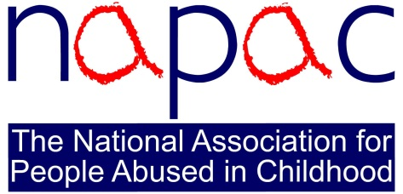

JOB DESCRIPTION

JOB ROLE | Survivor Support Facilitator
JOB FUNCTION | The Survivor Support Facilitators are accountable for the day to day delivery of NAPAC’s primary survivor support service – the telephone support line. They manage the NAPAC volunteers to provide telephone support to adult survivors of childhood abuse and those supporting them. Overall, they will have a commitment to delivery of excellence in everything NAPAC does for survivors and their supporters.
REPORTS TO | Senior Survivor Support Facilitator (Senior SSF)
REPORTING LINES | N/A
LOCATION | Stockport
HOURS OF WORK | 17.5 hours (0.5 FTE post) per week.

MAIN AREAS OF RESPONSIBILITIES

- Supervise/manage telephone support shifts (providing telephone and email support). Provide briefing, debriefing and live supervision of volunteers on a rota basis alongside the other Survivor Support Facilitators. This will include daytime and evening shifts with some evening work for training as required.

- Take support line calls regularly as required and requested by the Senior SSF.

- Work within NAPAC’s remit and promote implementation of any changes into working practice; this includes ensuring all volunteers follow NAPAC policies and procedures.

- Follow the agreed NAPAC model of managing and supporting volunteers, including training and supervision outside of support line shifts.

- Continually monitor and have awareness of the well-being of the volunteers; liaise with other Survivor Support Facilitators and the Senior SSF to ensure the best possible emotional wellbeing of the volunteers.

- Liaise with the other Survivor Support Facilitators in sharing information as appropriate and participate in handover shifts with other Survivor Support Facilitators.

- Contribute to the recruitment, initial training, induction and ongoing training of NAPAC volunteers along with and under the direction of the Senior SSF.

- Ensure quality of service to all callers whilst maintaining the integrity of the NAPAC model and the development and support of volunteers.

- Ensure regular contact with the volunteers, informing them of action plans, changes to policies and procedures and media coverage.

- Read the call information sheets and call handling data and support emails on a regular basis, monitoring and actioning issues in conjunction with the Senior SSF.

- Distribute and record volunteer expenses.

- Any other duties as directed by the line manager, Chief Operating Officer or CEO.

PERSON SPECIFICATION

The ideal person for the Survivor Support Facilitator role will have experience of working with survivors of childhood abuse, as well as knowledge and understanding of the issues raised by (or effects of) childhood abuse.

They will have proven experience in service provision in a therapeutic setting, as well as experience of working with volunteers.

The ideal person will have a strong track record in phone support work and support via written communication. Additionally, they will have experience of ICT systems, including maintenance of call management and data collection systems.

Excellent communication skills – oral and written – are essential for this role.

Resilience is a required feature of the ideal person for this role.

Successful achievement of a high standard of education is essential for this role and a recognised counselling qualification is desirable, as is a personal commitment to supporting adults abused in childhood.

Compassion and sensitivity to the cause, attention to detail, flexibility and agile in ways of working are essential. Being a team-player and demonstrating a ‘can-do’ attitude are also vital.

