Please help the Office for National Statistics decide whether placing the Crime Survey for England and Wales online would be safe for victim-survivors of domestic abuse, sexual offences, stalking and abuse in childhood | 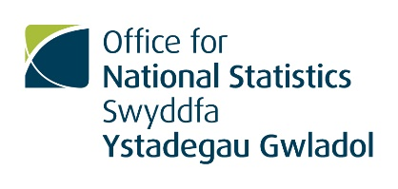
The Office for National Statistics (ONS) is the UK’s largest producer of official statistics and the recognised national statistics institute of the UK (www.ons.gov.uk). We conduct the important Crime Survey for England and Wales, which produces widely used statistics on levels of crime, including those not reported to the police (www.crimesurvey.co.uk).
We are looking for volunteers (aged 18 to 74) who have experienced abuse in childhood to take part in research to help us decide whether the Crime Survey would be suitable as an online survey. We’d like to hear your views on the nature of the questions the survey asks and other aspects of its design.
Your feedback will be invaluable. It will help us to minimise the risk of physical, emotional and psychological harm occurring to anyone due to responding to the survey online.
A focus group with ONS researchers will take place in private at a convenient and safe location, such as the address of a support group, one of the ONS offices in London, Newport (South Wales) or Titchfield (Hampshire), a hotel meeting room or another venue. It will take around an hour to ninety minutes and will be with about six to eight people who have also experienced one or more of the things listed above. We want to talk to people who have the ability to use websites to complete online surveys or application forms, but advanced skills are not needed and you will not have to use the internet in this research. Your personal information and everything discussed will be kept strictly confidential. (The only exception to this is if we are led to believe that someone is at risk of serious harm, in which case we may need to inform someone but would discuss your concerns with you first.) Our report on the research will not identify anyone who takes part.
Your wellbeing is extremely important to us. We do not require you to disclose details of your experiences. You would not have to answer the actual survey questions. However, it’s possible that discussing some aspects of the Crime Survey, including questions which are personal and graphic, may make you upset or recall traumatic experiences. Please also bear in mind that hearing other people’s experiences could have a similar effect on you. You would not to have to answer any question that you did not want to. You could take a break, change topic or leave the focus group at any time. We would ensure you could contact someone for support if necessary. However, if you are not in a good frame of mind at this time, this research is probably not for you.
We are offering £40 in vouchers or cash as a thank you for taking part. We will also consider covering reasonable expenses if that would enable you to attend.
If you are interested in taking part, please email social.research@ons.gov.uk or contact the support organisation who approached you, if relevant. Please let us know how we should contact you safely. We want to include a range of experiences and characteristics, so we will ask you to fill in a questionnaire. Then we will contact you again to let you know if you have been chosen for the research.

